SQL Labs

Note:
- The labs are to be implemented using the Northwind SQL Server database.
- The database contains the relevant tables with data.

Lab1: Simple SQL Queries to display specific columns
- Display CategoryName and Description from the Categories table.
use NORTHWND;

select * from INFORMATION_SCHEMA.COLUMNS where TABLE_NAME='Categories';

select top 10 CategoryName,Description
from Categories;
output:
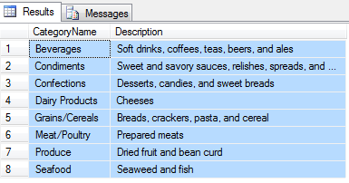

- Display ContactName, CompanyName, ContactTitle and Phone from the Customers table.
select * from INFORMATION_SCHEMA.COLUMNS where TABLE_NAME='Customers';

select top 10 ContactName,CompanyName,ContactTitle, Phone from Customers;

Output:
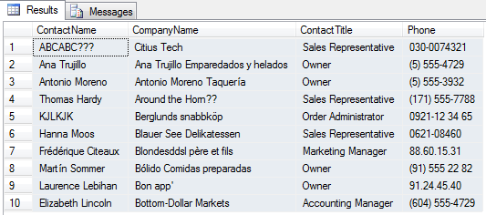
- Display EmployeeID, Title, FirstName, LastName, and Region from the Employees table.
select top 10 EmployeeID,Title,FirstName, LastName, Region from Employees;
output:
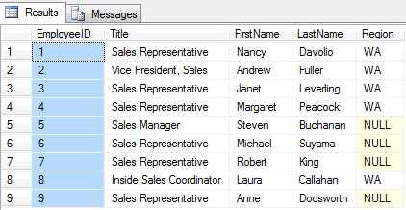

- Display RegionID and RegionDescription from the Region table.
select top 10 RegionID,RegionDescription from Region;
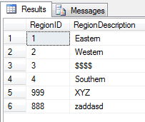
- Display CompanyName, Fax, Phone and HomePage from the Suppliers table.
Select top 10 CompanyName,Fax,Phone,HomePage from Suppliers;

Output:
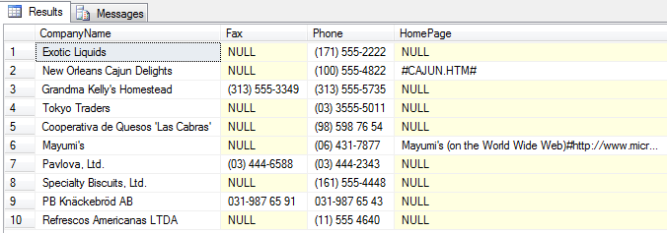

Lab2: Sorting data
- Display CategoryName and Description from the Categories table sorted by CategoryName.
select top 10 CategoryName,Description from Categories order by CategoryName;

Output:
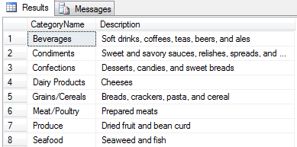
- Display ContactName, CompanyName, ContactTitle, and Phone from the Customers table sorted by Phone.
select top 10 ContactName,CompanyName,ContactTitle,Phone from Customers order by Phone;
Output:
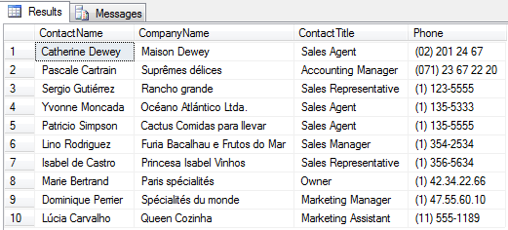
- Create a report showing employees' first and last names and hire dates sorted from newest to oldest employee.
select FirstName,LastName, HireDate from Employees order by HireDate Desc;
Output:
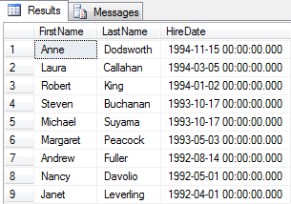
- Create a report showing Northwind's orders sorted by Freight from most expensive to cheapest. Show OrderID,OrderDate, ShippedDate, CustomerID, and Freight.
select top 10 OrderID,OrderDate,ShippedDate,CustomerID,Freight from Orders order by Freight desc;
Output:
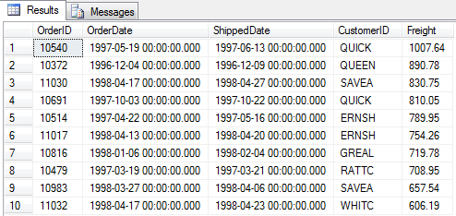
- Display CompanyName, Fax, Phone, HomePage and Country from the Suppliers table sorted by Country in descending order and then by CompanyName in ascending order.
select CompanyName,Fax,Phone,HomePage,Country from Suppliers Order by Country DESC,CompanyName;

Output:
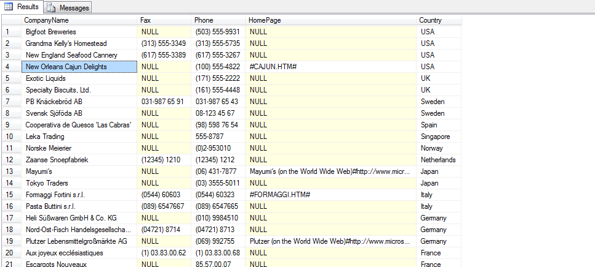
- Create a list of employees showing title, first name, and last name. Sort by Title in ascending order and then by LastName in descending order.
select Title,FirstName,LastName from Employees order by title,LastName desc;
Output:
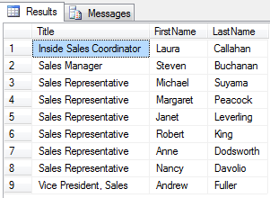

Lab3: Using the WHERE clause (1)
- Create a report showing all the company names and contact names of Northwind's customers in Buenos Aires.
select CompanyName,ContactName from Customers where City='Buenos Aires';
Output:
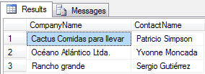
- Create a report showing the product name, unit price and quantity per unit of all products that are out of stock.
select ProductName,UnitPrice,QuantityPerUnit from products where UnitsInStock=0 ;
Output:
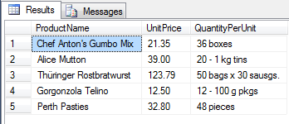
- Create a report showing the order date, shipped date, customer id, and freight of all orders placed on May 19, 1997.
select OrderDate,ShippedDate,CustomerID,Freight from orders where OrderDate = '1997-05-19';
Output:
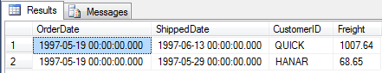
- Oracle users will have to use following date format: 'dd-mmm-yyyy' (e.g, '19-May-1997').
- MySQL users will have to use following date format: 'yyyy-mm-dd' (e.g, '1997-05-19').
- Create a report showing the first name, last name, and country of all employees not in the United States.
select FirstName,LastName,Country from Employees where Country != 'USA';
Output:
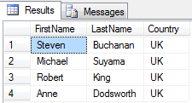

Lab4: Using the WHERE clause (2)
- Create a report that shows the employee id, order id, customer id, required date, and shipped date of all orders that were shipped later than they were required.
select top 10 EmployeeID,OrderID,CustomerID,RequiredDate,ShippedDate from orders where ShippedDate>RequiredDate;
Output:
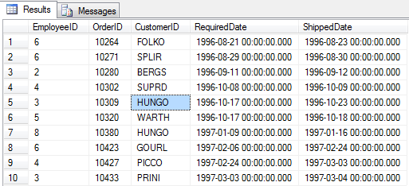
- Create a report that shows the city, company name, and contact name of all customers who are in cities that begin with "A" or "B."
select City,CompanyName,ContactName from customers where city like '[ab]%';
Output:
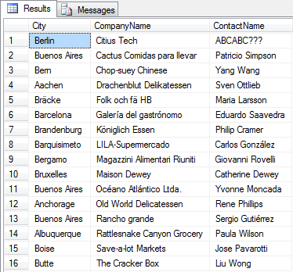
- Create a report that shows all orders that have a freight cost of more than $500.00.
select OrderID,OrderDate,CustomerID,EmployeeID,Freight from orders where Freight>500;
Output:
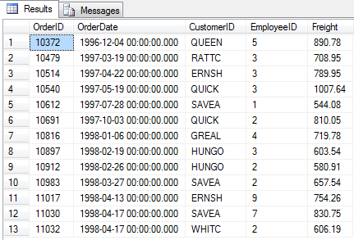
- Create a report that shows the product name, units in stock, units on order, and reorder level of all products that are up for reorder.
select ProductName,UnitsInStock,UnitsInStock,UnitsOnOrder,ReorderLevel from Products where ReorderLevel>0 order by ReorderLevel desc;
Output:
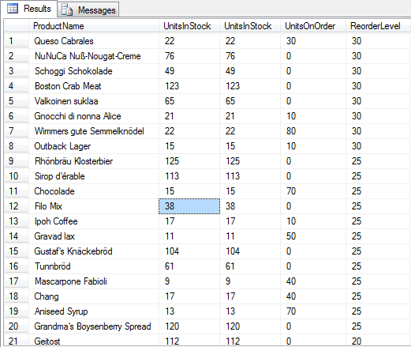
Lab5: Using NULL values
- Create a report that shows the company name, contact name and fax number of all customers that have a fax number.
- Create a report that shows the first and last name of all employees who do not report to anybody.

Lab6: Using WHERE & ORDER BY Together
- Create a report that shows the company name, contact name and fax number of all customers that have a fax number. Sort by company name.
- Create a report that shows the city, company name, and contact name of all customers who are in cities that begin with "A" or "B." Sort by contact name in descending order.

Lab7: Additional SELECT statements with WHERE
- Create a report that shows the first and last names and birth date of all employees born in the 1950s.
- Create a report that shows the product name and supplier id for all products supplied by Exotic Liquids, Grandma Kelly's Homestead, and Tokyo Traders. Hint: you will need to first do a separate SELECT on the Suppliers table to find the supplier ids of these three companies.
- Create a report that shows the shipping postal code, order id, and order date for all orders with a ship postal code beginning with "02389".
- Create a report that shows the contact name and title and the company name for all customers whose contact title does not contain the word "Sales".

Lab8: SELECT statements with multiple conditions
- Create a report that shows the first and last names and cities of employees from cities other than Seattle in the state of Washington.
- Create a report that shows the company name, contact title, city and country of all customers in Mexico or in any city in Spain except Madrid

Lab9: Calculating Fields
- Create a report that shows the unit price, quantity, discount, and the calculated total price using these three fields.
- Write a SELECT statement that outputs the following:
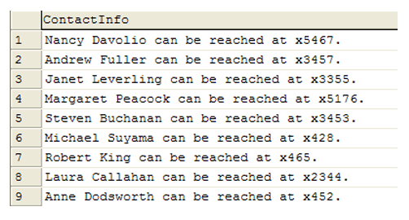
Lab10: Aggregate Functions
- Create a report that returns the following from the Order_Details table.
(The report should only return rows for which TotalUnits is less than 200)
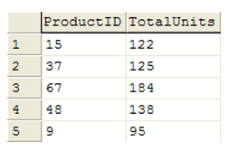

- Create a report that returns the following from the Products table.
(The report should only return rows for which the average unit price of a product is greater than 70)
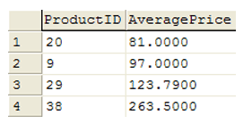

- Create a report that returns the following from the Orders table.
(NumOrders represents the number of orders placed by a certain customer. Only return rows where NumOrders is greater than 15)
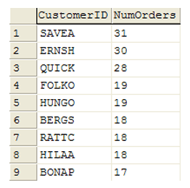

Lab11: DML Functions
- Create a report that shows the units in stock, unit price, the total price value of all units in stock, the total price value of all units in stock rounded down, and the total price value of all units in stock rounded up. Sort by the total price value descending.
- Create a report that shows the first and last names and birth month (as a string) for each employee born in the current month.
- Create a report that shows the contact title in all lowercase letters of each customer contact.

Lab12: Subqueries
- Create a report that shows the product name and supplier id for all products supplied by Exotic Liquids, Grandma Kelly's Homestead, and Tokyo Traders.
- Create a report that shows all products by name that are in the Seafood category.
- Create a report that shows all companies by name that sell products in CategoryID 8.
- Create a report that shows all companies by name that sell products in the Seafood category.

Lab13: Joins
- Create a report that shows the order ids and the associated employee names for orders that shipped after the required date.
- Create a report that shows the total quantity of products (from the Order_Details table) ordered. Only show records for products for which the quantity ordered is fewer than 200.
- Create a report that shows the total number of orders by Customer since December 31, 1996. The report should only return rows for which the NumOrders is greater than 15.
- Create a report that shows the company name, order id, and total price of all products of which Northwind has sold more than $10,000 worth.

Lab14: Unions
- Create a report showing the contact name and phone numbers for all employees, customers, and suppliers

Lab15: Using CASE
- Create a report that shows the company names and faxes for all customers. If the customer doesn't have a fax, the report should show "No Fax" in that field as shown below.
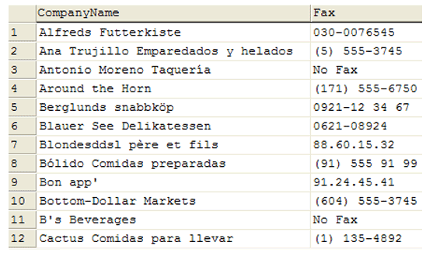

Labs on Views, Triggers & Stored Procedures

VIEWS
- Create the following tables: (The underlined column names are primary keys)
Activities (ActivityID, ActivityName)
Performers (PerformerID, PerformerName, Street, City, State, Zip, ActivityID)
Arenas (ArenaID, ArenaName, City, ArenaCapacity)
Concerts (PerformerID, ArenaID, ConcertDate, TicketPrice)

- Insert some sample records into each table.

Exercise 1: Write a SQL query to list all the performers’ name and the name of the activity the performer is involved in.
Exercise 2: Write a SQL statement to create a view called Act_perf based on the query in Exercise 1.
Exercise 3: Unlike a query, a virtual table or view can be used as if it is a table in the database. Now write a SQL query against the view as if it was a table: select everything from the view.
Exercise 4: IMPORTANT: The view does not store any data. The data is stored just in the tables used in the definition of view. When a query that uses Act_perf is executed, the system first evaluates the query that defines Act_perf, and then performs further evaluation of the query that uses Act_perf.
To demonstrate this, do the following:
a) Insert a row in Performers table (use INSERT INTO … VALUES …).
b) Execute SELECT * FROM Act_perf again.
Did the results changed? Why?

Exercise 5: (Updates on views)
Run the following query:
UPDATE Act_perf
SET PerformerName = 'Harry Chapinn'
WHERE PerformerName = 'Harry Chapin'
Does the query succeed? Why?
Execute “SELECT * FROM Performers” and check whether the name of Harry Chapin was changed to Harry Chapinn.

Exercise 6: Create a view called Perf_Income to show the name of the performer, the arena name, the date of the concert, and total_income. total_income represents the total payment received by a performer for a concert and is based on the fraction of ticket price that goes to the performer, and the total number of tickets sold. We assume that the artist receives 10% of the face value of each ticket and the number of tickets sold is always considered to be 80% of the arena capacity.

Exercise 7: SQL has a keyword “TOP n” that allows you to display only the first n rows in the result of a select query. For example “SELECT TOP 5 * FROM Performers” will display the first 5 rows from Performers table.
Write the SQL query on the Perf_Income view to show the top 8 concerts based on total income in order of highest income to lowest income.

Exercise 8: Write the SQL query to achieve the same result as above, but without using the Perf_Income view (you can still use TOP n). This query should look more complicated than the query in the previous exercise.

Exercise 9 (Extra credit): Write the SQL query to find the total money made by all of the artists during all the concerts (use the view).

Exercise 10 (Extra credit): Write the SQL statement (use the view) to update the total_income for ‘Jimmy Buffett’ to be $100,000. Run the query.

TRIGGERS
Exercise 1: Create a trigger called deletePerformer that prevents the last performer for a particular activity to be deleted from the database. The trigger should be associated with a delete operation on the Peformers table: if the performer to be deleted is the last one for his/her particular ActivityID, then the performer cannot be deleted. Otherwise, the performer should be deleted.
- Write and execute the code to create the trigger.
- Write and execute a DELETE statement that tries to delete the last performer for a particular activity from the database (look at the data in tables to find such a performer). Check the remaining rows in the Performers table. Is the performer you tried to delete still in Performers? Why?
- Write and execute a DELETE statement that tries to delete a performer from the database, when the performer is not the last one for the particular activity (look at the data in tables to find such a performer). Check the remaining rows in the Performers table. Is the performer you tried to delete still in Performers? Why?

STORED PROCEDURES
Exercise 1: Create a stored procedure called spInsertConcert that inserts a new concert into the database, under some conditions. The stored procedure has as input parameters performer id, arena id, concert date, and ticket price. The stored procedure should insert a row in the Concerts table only if the following conditions are true:
- There is no other concert by the same performer on the same date (in that case, the performer is already busy) AND
- There is no other concert in the same arena for that date (arena is busy).

If the above conditions are not true, the procedure should print an explicative message and terminate.

